
Software Engineering Department
Braude College

Capstone Project Phase B – 61999

Spectral Filtering for Community-Based Anomaly Detection in Attributed Graphs
25-2-R-11

Students:

Itay Mohabati
Shai Yosef

Supervisors:
Dr. Renata Avros
Prof. Zeev Volkovich

GitHub:
https://github.com/ItayMoh/Community-Based-Spectral-Filtering-Anomaly-Detection-Framework
Table of Contents
1. Introduction 3
2. Related Work 4
3. Project Workflow 5
4. General Description 7
4.1 Project Goal 7
4.2 Target Audience 7
4.3 Solution Architecture 7
4.4 Framework Algorithms 8
4.5 Operation Flow 9
5. Research and Development Process 9
6. Challenges and Solutions 10
7. Experiments and Results 11
7.1 Datasets with Injected Anomalies 11
7.1.1 Results for Injected Anomalies Using GCN 12
7. 2 Datasets with Natural Anomalies 14
7.2.2 Results for Natural Anomalies Using GCN 14
8. Conclusions 15
9. User Guide 16
9.1 Running the Project 16
9.1.1 Opening the Project in Google Colab 16
9.1.2 Notebook Execution 16
9.2 Input Data 17
9.3 Explanation of Diagrams and Results 17
9.3.1 Results Folder Files 17
9.3.2 Results Interpretation 18
10. Guide Maintenance 19
10.1 Project Overview and Goal 19
10. 2 Notebook Design 19
10.3 Data Directory and File Access 20
10.4 Results Directory 20
10.5 Dependencies 21
10.5.1 Python Libraries 21
10.5.2 Execution Environment 21
10.6 Maintenance and Modification Notes 21
10.6.2 Dataset Structure Sensitivity 22
10.6.3 Extending the Project 23
10.6.4 Known Limitations 23

1. Introduction
Detecting anomalous behavior in graph-structured networks is a fundamental challenge in many real-world domains, particularly when such networks exhibit strong community structure. Traditional anomaly detection methods often focus on global irregularities and fail to identify subtle, context-dependent deviations that occur within communities. This limitation is especially pronounced in attributed graphs, where both structural relationships and node-level features must be considered.
To address this challenge, this project presents a novel framework for anomaly detection in community-structured networks using a spectral filtering-based approach. The methodology integrates graph embedding techniques, including GraphSAGE and GCN, to generate informative node embeddings that capture both structural and attribute information. These embeddings are subsequently clustered to identify communities, which serve as the foundation for community-aware anomaly detection.
The core of the framework is the SpecF algorithm, a spectral graph theory-based method designed to detect anomalous nodes within communities. SpecF applies the Graph Fourier Transform and a low-pass spectral filter to evaluate the smoothness of node-level signals within their respective communities. Nodes that exhibit significant deviations from this smoothness are identified as potential anomalies, enabling the detection of irregular behavior that traditional clustering-based methods may overlook.
By combining embedding-driven community detection with spectral anomaly scoring, the proposed approach addresses key challenges related to scalability, structural complexity, and contextual relevance in graph-structured data. The framework is particularly applicable to domains such as fraud detection, social network analysis, and citations networks, where anomalies are often subtle and inherently dependent on community context.

2. Related Work
Prior research on anomaly detection in attributed graphs spans several interconnected fields, including community detection, graph-based anomaly detection, graph signal processing, and graph embedding techniques. Community detection methods effectively identify structural partitions in networks but are not designed to detect anomalous nodes within communities. Similarly, traditional graph anomaly detection approaches primarily focus on global outliers and often overlook local, community-dependent irregularities.
Graph Signal Processing introduces spectral tools such as the Graph Fourier Transform and spectral filtering to analyze signal smoothness over graphs. While effective for identifying irregular patterns, most GSP-based methods apply global filtering and do not explicitly account for community structure, limiting their ability to detect localized anomalies. Graph embedding methods, including random-walk-based and neural network-based approaches, provide informative node representations but typically require additional processing to identify anomalies and do not inherently model community-specific deviations.
Existing spectral filtering approaches further suffer from limited community awareness, reliance on supervised learning, and the absence of joint structural–community encoding. These limitations motivate the proposed SpecF-based approach, which incorporates community-aware spectral filtering to enable unsupervised, context-sensitive anomaly detection within complex attributed networks.

3. Project Workflow
The project workflow is designed to detect anomalous behavior within communities in attributed graphs. It proceeds through a series of structured stages, each building upon the outputs of the previous step to incrementally refine the representation of the network and identify irregularities.
The process starts by obtaining a graph where nodes correspond to articles, and edges represent citation links. Each node is associated with a feature vector based on the article’s bag-of-words representation.
The next step involves generating node embeddings using graph representation learning techniques. Two primary models are used: Graph Convolutional Networks (GCN) and GraphSAGE. These models integrate both the local structure of the graph and the attribute information of the nodes to produce compact, information-rich embeddings. These embeddings map each node to a vector in a lower-dimensional space, preserving structural and semantic proximity.
After embedding, the resulting node vectors are clustered using the K-means algorithm. Unlike traditional community detection methods that rely purely on topological properties, clustering in the embedding space enables the identification of communities based on both connectivity and attribute similarity. The number of clusters $k$ is predefined, and each node is assigned to one of the resulting communities based on its proximity to cluster centroids.
Before anomaly detection, Signal Generation is performed to assign a scalar signal to each node. These signals reflect expected behaviors within each community. To test the anomaly detection system, an optional Signal Injection step introduces synthetic anomalies by perturbing the signal values of selected nodes, simulating unusual or unexpected behaviors within the graph.
Following signal generation and injection, the core of the anomaly detection mechanism is applied. The SpecF (Spectral Filtering) algorithm processes a node-level signal over the graph, and transforming it into the spectral domain using the Graph Fourier Transform (GFT). A low-pass filter is then applied, suppressing high-frequency components associated with irregular or noisy behavior. The filtered signal is subsequently compared to the original signal, and nodes exhibiting large residuals are identified as potential anomalies.
To enhance sensitivity to context, the filtering and scoring are performed within each community using a modified Laplacian that encodes both structural and community membership information. Each community is assigned a dynamic anomaly threshold based on its internal deviation statistics, allowing detection to be tailored to the unique characteristics of each group.
The workflow outputs node-level anomaly scores and a list of detected anomalies, representing nodes whose behavior deviates significantly from their community norms. These results were used to visualize and interpret anomalous patterns in the network and to assess the effectiveness of the proposed detection framework.
In summary, this modular and unsupervised framework integrates graph embedding, clustering, and spectral filtering to deliver robust and context-aware anomaly detection in networks with community structure.
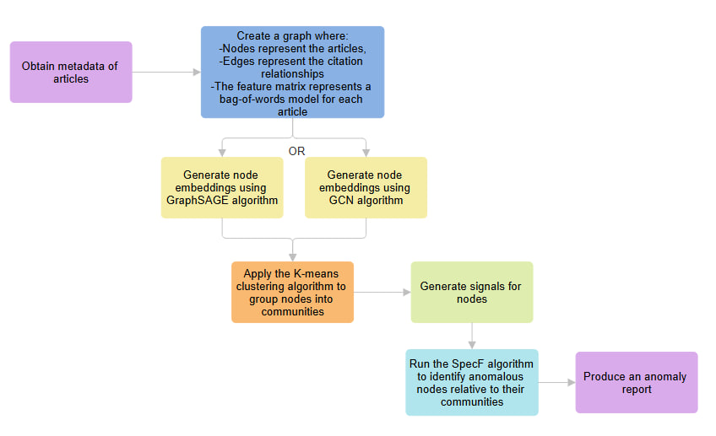

4. General Description

4.1 Project Goal
The primary goal of this project is to detect anomalous nodes within attributed networks (e.g., social or citation graphs) by leveraging their community structure. Unlike traditional methods that look for global outliers, this solution focuses on community-based anomaly detection, identifying nodes that deviate from the expected smooth behavior of their local group, addressing the challenge where subtle anomalies are hidden by the global network.
The solution is implemented as a modular framework integrating deep learning for graph representation with signal processing. It follows a structured three stage workflow: first learning the network structure through graph embeddings, then identifying communities, and finally applying a spectral filtering method (SpecF) to detect deviations from normal behavior.

4.2 Target Audience
The framework is designed for professionals and researchers who analyze graph-structured data and seek reliable, community-aware anomaly detection methods.
- Academic Researchers in Graph Mining and Network Science
- Data Scientists and Machine Learning Engineers
- Domain Experts in Applied Network Analysis.

4.3 Solution Architecture
The solution is structured as a Python-based analysis framework built to run in Google Colab. It follows a modular, layered architecture that promotes scalability, clarity, and extensibility for future enhancements.
- Data Layer: this layer is responsible for loading the attributed graph dataset. The output of this layer is a structured graph containing feature matrix, edge list and any available node metadata.
- Modeling Layer: this layer learns node embeddings using GNN models (GCN and GraphSAGE) implemented in PyTorch. The output is an embedding matrix $Z∈R^{n×d}$that captures both network structure and node attributes and serves as the basis for community discovery and signal construction.
- Evaluation Setup Layer: inject controlled anomalies into the graph signal to create a known ground-truth set $P$. This enables quantitative validation of detection performance.
- Analysis Layer: this layer performs community discovery and anomaly detection:
  - Community Discovery: Applies K-means on embeddings $Z$to assign each node a community label.
  - Spectral Filtering (SpecF): The main anomaly detector. It smooths each community’s signal using a low-pass filter, then flags nodes whose original values differ most from the smoothed estimate, indicating they deviate from the expected community behavior.

4.4 Framework Algorithms
- Graph Embeddings (GCN & GraphSAGE): The framework first maps nodes to low-dimensional vectors. GCN (Graph Convolutional Networks) learns embeddings by aggregating information from a node's neighbors to capture local structure. GraphSAGE produces embeddings by sampling and aggregating neighborhood information, making the representation learning step more scalable for large graphs.
- Community Detection (K-Means): Next, the generated embeddings are clustered using the K-Means algorithm. Each node receives a community label based on embedding similarity. These communities are used later for constructing community-aware signals and for interpreting anomalies relative to their peers.
- Signal Generation: the framework constructs a node-level signal $B$ that represents expected behavior with respect to community context. This step converts the graph into a graph-signal processing problem, where normal behavior should appear smoothly within communities.
- Synthetic Anomaly Injection (optional): The framework includes a controlled injection mechanism to create ground-truth anomalies for evaluation. A subset of nodes is selected according to an anomaly ratio, and their signal values are perturbed using an intensity parameter $θ$to simulate abnormal behavior. This produces a known anomaly set $P$, enabling direct measurement of detection performance.
- SpecF (Spectral Filtering): This is the core research innovation. It constructs a similarity graph for each community and computes its Laplacian matrix. By applying the Graph Fourier Transform (GFT) and a low-pass spectral filter, the algorithm isolates high-frequency signals. Nodes with high energy in high frequencies are flagged as anomalies because they disrupt the signal smoothness of their community.

4.5 Operation Flow
- Input: Load the attributed graph dataset (Nodes, Edges, Features).
- Embedding Generation: run GCN or GraphSAGE model to produce low-dimensional node embeddings.
- Detect Communities: Apply K-Means on the embeddings to assign a community label to every node.
- Signal Generation: Build a community-aware node signal that represents expected behavior relative to its community context.
- Optional: Inject synthetic anomalies: Select a subset of nodes and perturb their signal values using intensity $θ$to create ground-truth anomalies.
- Spectral Filtering: Apply low-pass spectral filtering to estimate the smooth signal $B^{'}$, then compute residual scores $y_{i}=∣b_{i}-b_{i}^{'}∣$.
- Thresholding: Anomaly scores are compared against a community-specific threshold, and nodes exceeding it are flagged as anomalous.
- Output: The final output is the set of anomalous nodes detected.

5. Research and Development Process

Research and Problem Framing
The process began with a literature review identifying that existing graph anomaly detection methods identify global outliers but often miss community-dependent anomalies. This led us to focus on a community-aware perspective and adopt the SpecF hypothesis that anomalies appear as irregular (non-smooth) behavior relative to a local group.
Planning and Project Design (Phase A)
In Phase A, we translated the research idea into a practical plan. Defining the framework stages, inputs and outputs, and how each module connects. We also decided on the experimental strategy using synthetic anomalies for evaluating purposes.
Implementation (Phase B)
In Phase B, we implemented the planned workflow in Python using Google Colab, building the project as modular notebooks so each dataset and model configuration can run independently and produce consistent outputs (tables and plots).
Verification via Synthetic Experiments
To verify correctness, we injected controlled anomalies on the Cora, CoraFull and PubMed datasets to create ground truth, then measured whether the framework successfully identifies the injected nodes while varying the anomaly intensity $θ$ and the anomaly ratio $AN$.
Real-Data Unsupervised Exploration
After validation, we applied the same workflow without anomaly injections on the Cora, PubMed and OpenAlex datasets, computed deviation scores $y_{i}$for all nodes and then flagged nodes with the largest deviations as anomalous candidates based on their community context.
Iteration and Refinement
Across both experiment types, we evaluated and enhanced the results visualization for clearer interpretation and streamlined the code to enable simpler execution.

6. Challenges and Solutions
- Dataset Metadata Limitation: the Cora dataset provided by the Planetoid benchmark lacks rich metadata such as paper titles, authors, and publication dates.
Solution: We located the original Cora dataset released by its creator, Andrew McCallum, and reconstructed a dataset consistent with the Planetoid version (same feature dimensionality, class labels, and graph structure), enabling more detailed and context-aware experiments.
- Testing Challenge: Verifying that the SpecF algorithm and the complete framework correctly detect anomalies.
Solution: We used a synthetic anomaly injection mechanism, allowing evaluation of detection performance using controlled ground truth.
- Community Awareness Challenge: Ensuring anomaly detection is performed relative to local community structure rather than global graph behavior.
Solution: Communities are identified using K-Means clustering in the embedding space and SpecF uses these assignments to compute anomaly scores relative to community norms.
- Model Consistency Challenge: Ensuring stable anomaly detection performance across different graph embedding models.
Solution: The framework is evaluated using GCN and GraphSAGE graph embedding models to verify consistency and robustness of results.
- Sensitivity Challenge: Detecting subtle deviations that may be overlooked by traditional approaches.
Solution: Anomaly scores are computed from spectral residuals $y_{i}=∣b_{i}-b_{i}^{'}∣$ between original and low-pass filtered signals, enabling the framework to highlight even minor deviations from the expected (filtered) signal.

7. Experiments and Results

7.1 Datasets with Injected Anomalies
To evaluate detection performance, we employed a synthetic anomaly injection mechanism in which node signals were modified to create controlled ground-truth anomalies.
Starting from clean graph embeddings, anomalies were artificially introduced into a selected subset of nodes. This process provided full ground truth and enabled evaluation.
Two key parameters governed the injection process:
- Anomaly Ratio - the percentage of nodes modified in the graph.
- Anomaly Intensity ($θ$) - the strength of the modification applied to anomalous nodes.
The modified embeddings were then processed through the complete SpecF workflow, and performance was evaluated using accuracy, false positive rate, and false negative rate. This experimental phase was designed to assess the correctness, robustness, and sensitivity of the algorithm across a wide range of anomaly scenarios.
Impact of Anomaly Ratio:
For $θ=0$, The framework exhibited its most stable and reliable behavior when anomalies constituted approximately 5-10% of the nodes, a range that reflects realistic anomaly prevalence. Within this interval, detection performance remained consistently high, with low false positive and false negative rates. As the anomaly ratio increased beyond this range, performance gradually deteriorated. This degradation occurs because a large concentration of anomalous nodes distorts the underlying definition of community normality, leading to a trade-off between correctly identifying anomalies and introducing spurious detections.
Impact of Anomaly Intensity ($\text{θ}$):
Across standard experimental configurations using both GCN and GraphSAGE embeddings, the framework consistently detected a substantial portion of the injected anomalies. However, increasing the anomaly intensity beyond moderate levels did not always yield improved detection. At very high values of $θ$, a counterintuitive increase in false negatives was observed. This effect arises from the spectral low-pass filtering mechanism, which aggressively smooths extreme signal deviations toward the community mean, thereby reducing the residual anomaly score
$$y_{i}=∣b_{i}-b_{i}^{'}∣.$$This behavior highlights that the proposed SpecF-based approach is particularly effective at identifying subtle, structurally embedded anomalies, rather than trivial, high-magnitude outliers.

7.1.1 Results for Injected Anomalies Using GCN
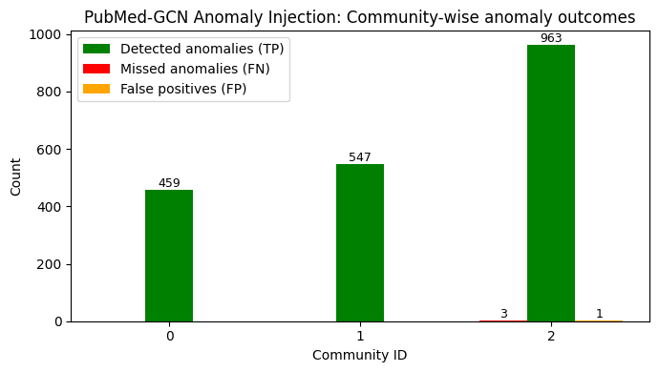
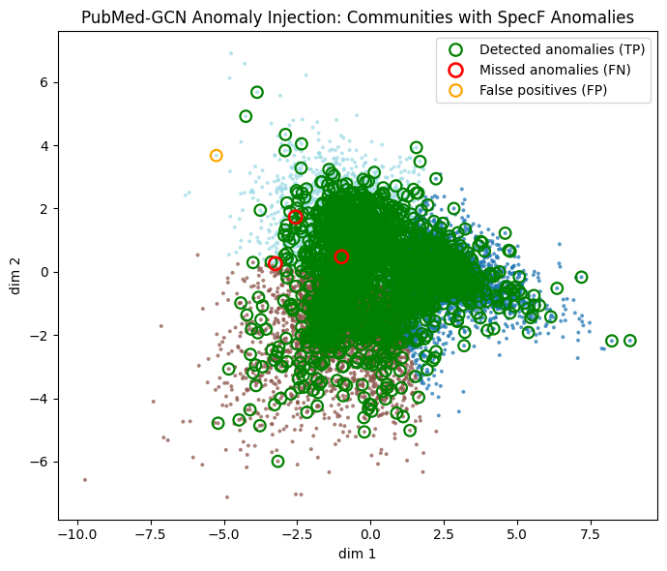
PubMed Dataset
Cora Dataset
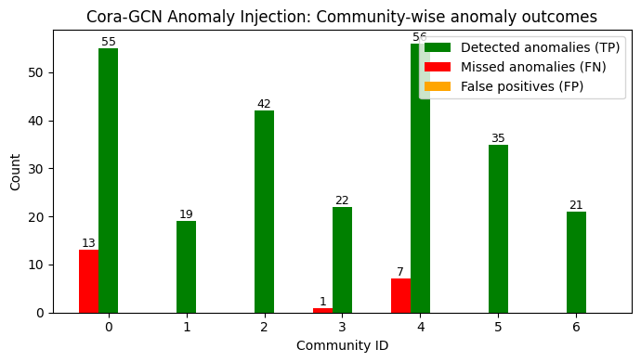
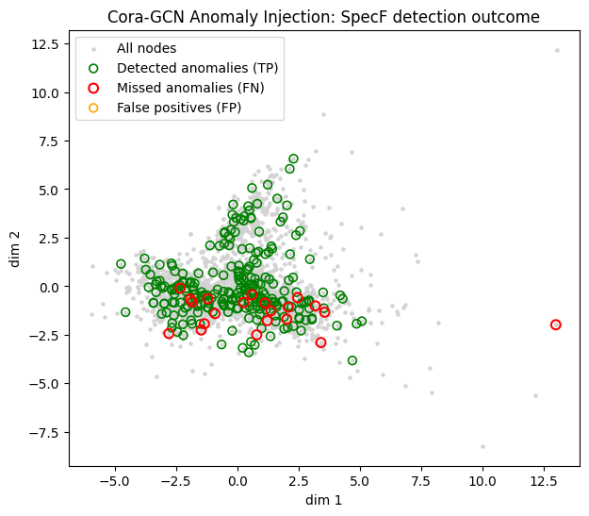

CoraFull Dataset
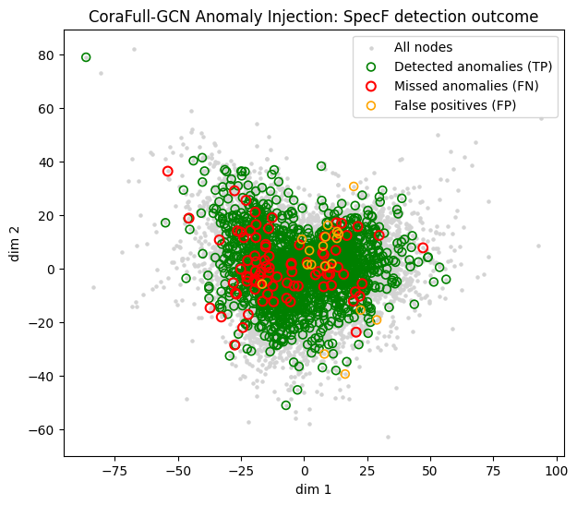

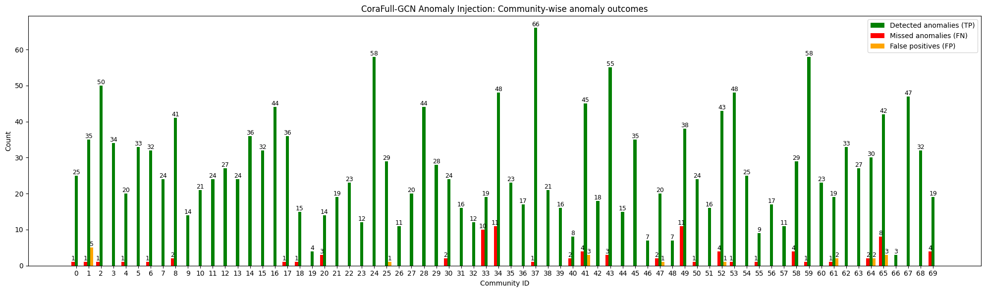

7. 2 Datasets with Natural Anomalies
To assess performance under realistic conditions, we applied the same end-to-end workflow without injecting anomalies. Node embeddings produced by GNN models were analyzed directly by SpecF, and anomaly scores $y_{i}$ were computed for all nodes based solely on their spectral properties. In the absence of ground-truth labels, evaluation focused on:
- Relative anomaly scores
- Community-level patterns
- Structural and semantic coherence of detected outliers.
Structural Outliers and Bridge Nodes: The SpecF algorithm successfully highlighted nodes with high deviation scores $y_{i}$ that often correspond to interdisciplinary papers bridging multiple research fields, as well as seminal papers exhibiting atypical citation patterns relative to their assigned communities.
Contextual Sensitivity: Unlike traditional anomaly detection approaches that primarily identify global outliers (e.g., nodes with extreme degree values), the proposed system detects nodes that deviate from the expected smooth behavior of their local communities. This demonstrates the framework’s ability to capture context-aware irregularities, such as a paper assigned to a Computer Vision community that exhibits unusually weak citation links to other vision-related papers.

7.2.2 Results for Natural Anomalies Using GCN
PubMed Dataset

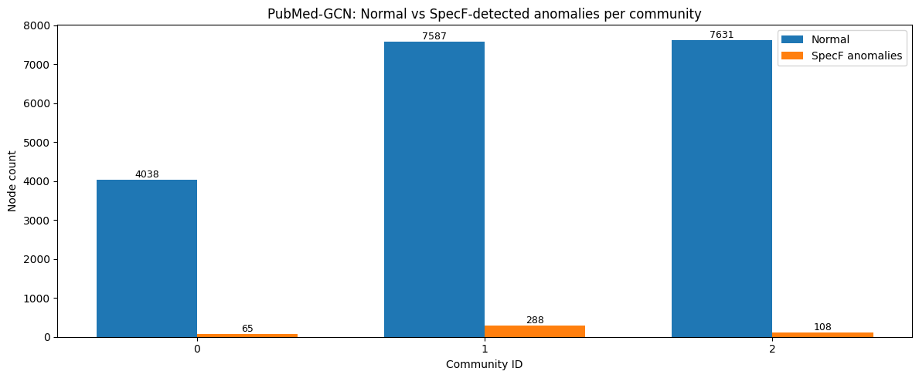
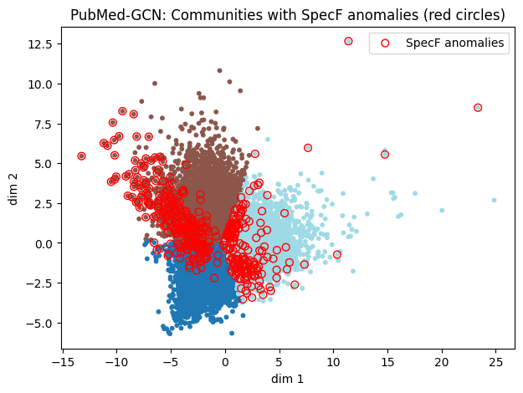

Cora Dataset
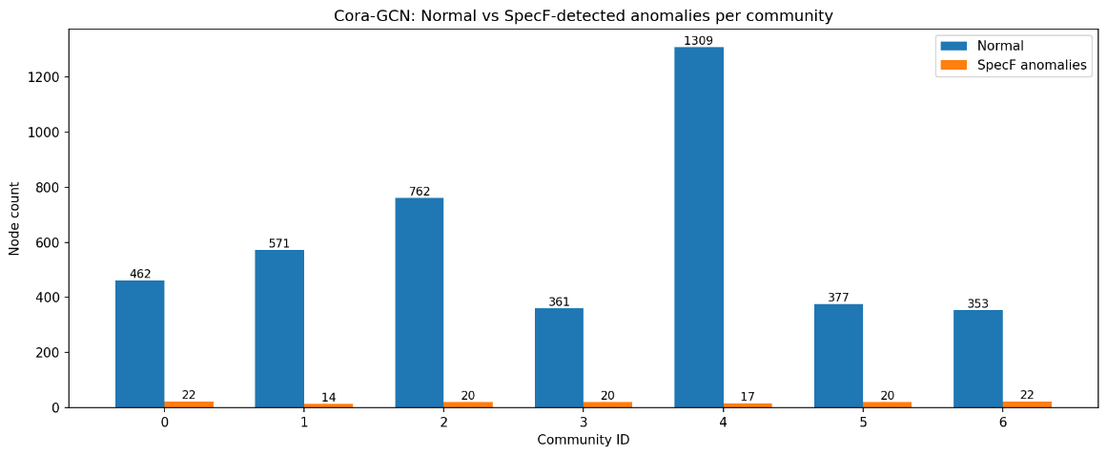
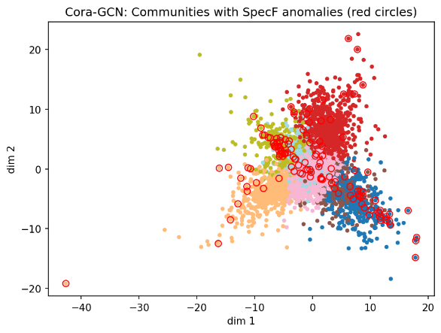

OpenAlex Dataset
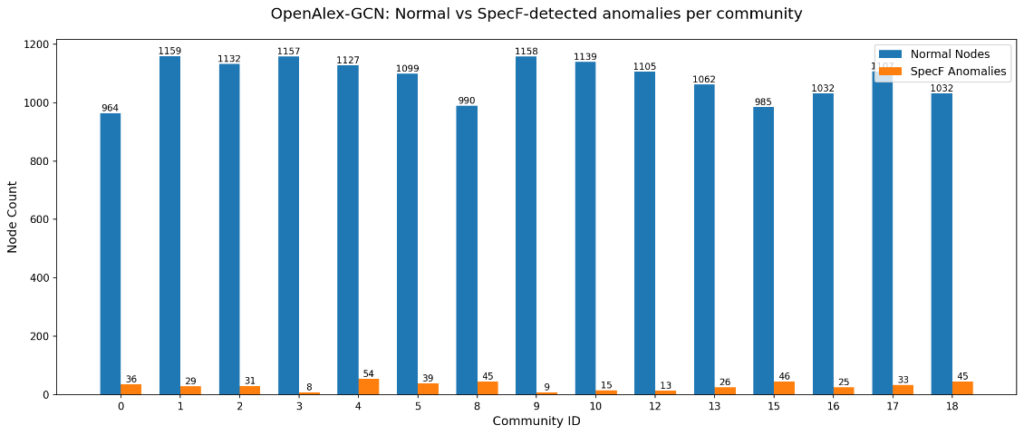
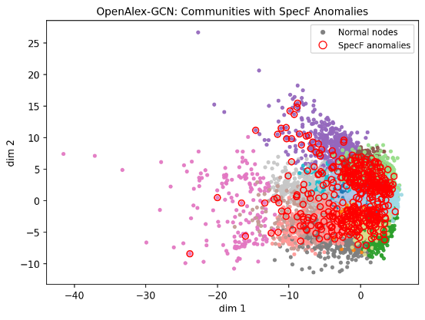

8. Conclusions
This work investigated the effectiveness of a spectral graph–based anomaly detection framework (SpecF) through both controlled and semi unsupervised experiments. The results lead to several key conclusions.
First, experiments with synthetic anomaly injections demonstrate that SpecF is capable of reliably detecting anomalous nodes when deviations are sparse and realistic. The algorithm achieved its best performance when anomalies constituted a small fraction of the graph, confirming its suitability for real-world scenarios. Detection accuracy remained high across different graph embedding models, indicating that the method is robust to the choice of node representation.
Second, the experiments revealed an important limitation of spectral filtering methods. When the anomaly ratio becomes too large, or when anomaly intensity $θ$ is extremely high, the definition of “normal” graph behavior becomes distorted. In such cases, strong deviations may be partially suppressed by the low-pass spectral filter, leading to an increase in false negatives. This highlights a fundamental trade-off between smoothing and sensitivity in spectral approaches.
Third, applying the same workflow without injecting anomalies showed that SpecF operates effectively in a semi unsupervised setting. Even in the absence of ground truth, the algorithm produces meaningful anomaly scores that align with structural and semantic irregularities in the graph. This confirms that SpecF can be used as an exploratory tool for discovering unexpected or abnormal patterns in real data.
Overall, the experiments demonstrate that SpecF is a stable and semi unsupervised anomaly detection method for graph-structured data. While its performance is strongest in sparse-anomaly regimes, the insights gained from the experiments clarify both its strengths and its limitations, providing clear guidance for practical deployment and future improvements.

9. User Guide

9.1 Running the Project

9.1.1 Opening the Project in Google Colab
Open each project notebook using Google Colab:
- GCN_Experiments_Cora_NoAnomalies_Final.ipynb
- GCN_Experiments_PubMed_NoAnomalies_Final.ipynb
- GraphSAGE_Experiments_Cora_NoAnomalies_Final.ipynb
- GraphSAGE_Experiments_PubMed_NoAnomalies_Final.ipynb
The project is designed to run in a standard Colab environment and does not require local installation.

9.1.2 Notebook Execution
The project does not require manually uploading data files into Colab.
Required datasets are either downloaded automatically from Google Drive using shared links.
There is no strict execution order between notebooks.
Each notebook represents a separate experimental configuration (dataset $×$ model).
Users may run any single notebook independently.

9.2 Input Data
Input data includes:
- Graph structure (nodes and citation edges)
- Node-level features
- Auxiliary metadata (e.g., paper titles, paper subjects).
Users do not need to prepare or preprocess the input data manually.

9.3 Explanation of Diagrams and Results

9.3.1 Results Folder Files
results of both datasets
KMeans_vs_GroundTruth.png - evaluation of K-Means clustering results compared against ground-truth labels.
SpecF_scores_with_anomalies.png - visualization of spectral anomaly scores assigned to nodes after filtering and visualizing the detected anomalies.
InputSignal_B_with_anomalies.png - visualization of the generated node signal used as input to the spectral filtering stage.
Communities_with_SpecF_anomalies.png - visualization of communities containing SpecF detected anomalies.
SpecF_detected_anomalies.png - visualization of nodes identified as anomalous by the spectral filtering method.
Normal_vs_SpecF_anomalies_per_community.png - comparison between number of normal nodes and SpecF anomalies at the community level.
SpecF_scores_per_community.png - distribution of spectral deviation scores per node within each community highlighting SpecF detected anomalies.
SpecF_scores_per_community_minYi_highlighted.png – same as SpecF_scores_per_community.png but with the minimum SpecF score highlighted.
SpecF_detected_anomalies_per_community.png - distribution of detected anomalies across communities.
SpecF_per_community_minYi_highlighted.png – same as SpecF_detected_anomalies_per_community.png but with the minimum SpecF score highlighted.
SpecF_anomalies_per_community_onlyCommunityNodes.png - community-level view focusing on SpecF detected anomalies.
Files Unique to the Cora Dataset
Cora_specf_anomalies_GCN.xlsx, Cora_specf_anomalies_GraphSAGE.xlsx - tabular summary of nodes flagged by SpecF contains their node id, subject id, subject name, community id, and SpecF score.
Cora_top5_titles_per_community_GCN.xlsx, Cora_top5_titles_per_community_ GraphSAGE.xlsx - top 5 titles per community for normal nodes and anomalies nodes.
Dominant_subjects_per_community_vs_anomalies.png - relationship between dominant subjects within communities and dominant subjects within detected anomalies.
Normal_vs_SpecF_anomalies_per_subject.png - comparison between number of normal nodes and SpecF anomalies grouped by subject.
Files Unique to the PubMed Dataset
PubMed_SpecF_anomalies_GCN.xlsx, PubMed_SpecF_anomalies_GraphSAGE.xlsx - tabular summary of nodes flagged by SpecF contains their title, label id, community id and SpecF score.
PubMed_top5_titles_per_community_GCN.xlsx, PubMed_top5_titles_per_community_ GraphSAGE.xlsx – top 5 titles per community for normal nodes and anomalies nodes.

9.3.2 Results Interpretation
The system works in four conceptual stages:
- Graph-based embedding generation
- Community discovery
- Spectral anomaly detection (SpecF)
- Result aggregation and visualization

What Detected Anomalies Mean
A detected anomaly is a paper whose structural or embedding-based behavior is inconsistent with most papers in its community.
These anomalies indicate papers that may:
- Bridge different research topics
- Exhibit atypical citation behavior
- Belong structurally to one community but topically to another.
How to Read the Results
- Node-level plots show which individual papers deviate strongly from expected behavior.
- Community-level plots show whether anomalies are isolated or concentrated within specific communities.
- Subject comparison plots reveal whether anomalous papers follow the dominant topic of their community or represent topic-divergent behavior.
- Tabular outputs list flagged papers and representative titles to support qualitative inspection.

10. Guide Maintenance

10.1 Project Overview and Goal
This project investigates graph-based anomaly detection in citation networks by combining Graph Neural Network (GNN) embeddings with community discovery and spectral filtering (SpecF). The goal is to identify anomalous nodes whose deviate from their local community structure.
The framework learns node embeddings using GCN and GraphSAGE, identifies communities via K-means clustering in the embedding space, and then applies the SpecF spectral method to compute community-conditioned deviation scores for anomaly detection.

10. 2 Notebook Design
The project is implemented using four independent Jupyter notebooks.
- GCN_Experiments_Cora_NoAnomalies_Final.ipynb
- GCN_Experiments_PubMed_NoAnomalies_Final.ipynb
- GraphSAGE_Experiments_Cora_NoAnomalies_Final.ipynb
- GraphSAGE_Experiments_PubMed_NoAnomalies_Final.ipynb
Each notebook is self-contained and can be executed individually in a fresh Google Colab session without relying on output generated by other notebooks.
each notebook includes the complete end-to-end workflow, consisting of:
- Data loading and preprocessing (Cora or PubMed)
- Graph construction and feature preparation
- GNN-based embedding generation (GCN or GraphSAGE)
- K-Means clustering for community assignment
- Spectral and community-based anomaly detection
- Evaluation and result visualization

10.3 Data Directory and File Access
The project relies on a shared data folder located in Google Drive. The notebooks download the relevant data using gdown and save the files into the Google Colab environment at runtime and serve as a data source.
This folder contains:
- original_cora_preprocessed.pt - a preprocessed PyTorch Geometric object containing the Cora dataset.
- pubmed-diabetes.zip - a compressed archive containing the raw PubMed dataset (graph + labels + features).
- pubmed-new.zip - textual metadata (titles) for PubMed dataset.
The Google Drive file IDs (download links) are specified in the notebooks and may need to be updated if the files are replaced, or their IDs change.
  - Results Directory
All outputs are saved automatically to a local /Results directory in the Google Colab runtime environment. This directory is created during execution and stores the generated results.
The directory contains:
- Visualization files (.png) illustrating analysis results.
- Tabular summaries (.xlsx) listing detected anomaly candidates with their titles and community context for qualitative inspection.

10.5 Dependencies

10.5.1 Python Libraries
The project is implemented in Python and relies on standard scientific and machine learning libraries, including:
- Core computation and data handling (numpy, pandas, scipy, gdown)
- Graph processing (network, torch, torch-geometric)
- Machine learning and evaluation (scikit-learn - used for K-Means clustering, PCA, and evaluation metrics)
- Visualization (matplotlib)
- Excel output generation (openpyxl)
- Notebook utilities (IPython.display)
- Utility and preprocessing (os, pathlib, zipfile, math, random, re, collections, itertools)
All libraries are imported directly within the notebooks, and no external or custom packages are required.

10.5.2 Execution Environment
The project is designed to run in a standard Google Colab environment.
Key characteristics:
- No local installation is required.
- Required dependencies are installed within the Colab runtime via pip (e.g., torch, torch_geometric, gdown).
- GPU acceleration is optional and may be enabled for faster GNN training.
- Since Colab runtimes reset between sessions, datasets must be re-downloaded at the start of each run.

10.6 Maintenance and Modification Notes
10.6.1 Dataset Access and Path Configuration
Each notebook defines
- Google Drive file IDs used to download datasets via gdown
- Local results directory path where the outputs are saved in Google Colab runtime environment.
To modify file ID:
- Upload the dataset file to Google Drive
- Set sharing permission as "Anyone with the link → Viewer"
- Copy the file's ID from its sharing link
- For Cora: update FILE_ID in the notebook (cell number 4)
- For PubMed: update the corresponding entry in the FILES dictionary (cell number 4).
- The notebook downloads the file via gdown and extracts it under /content/Data/ in the Google Colab runtime environment.
To modify Results directory path:
Update the variable RESULTS_DIR that defines it in the notebook cells.

10.6.2 Dataset Structure Sensitivity
If the internal structure of the dataset changes, the following parts of the system may break or produce incorrect results:
- Graph construction - changes in node or edge representation may prevent correct construction of the citation graph.
- Embedding generation - changes in feature or signal construction may affect the ability of the GNN models to generate valid node embeddings.
- Community detection - alterations in embedding dimensionality or distribution may affect K-Means clustering behavior and community assignments.
- Spectral filtering (SpecF) - changes in graph topology or signal definition may invalidate assumptions used by the spectral filtering process, leading to unstable or misleading anomaly scores.
- Aggregation and visualization - missing or altered metadata may cause errors in community-level aggregation, result summaries, or visualization routines.

10.6.3 Extending the Project
Common maintenance actions include:
- Use Additional or Alternative Datasets.
- Experiment with Different GNN Encoders.
- Modify Community Detection Strategy.
- Changing how node-level signals are constructed.
- Adjusting anomaly scoring or thresholding criteria.
- Adjusting the number of clusters $K$used by K-Means.
- Adding new visualizations to support alternative analyses or reporting needs.
Due to the self-contained notebook design, such changes can typically be applied independently per notebook without affecting the rest of the project.

10.6.4 Known Limitations
- The number of clusters $\text{K}$must be chosen manually.
- In some cases, strong or structured deviations may be smoothed by the graph spectrum, potentially reducing detectability.
- The system has not been optimized for large-scale or production environments.

